Lab 1: UML Design using Visio
Due: Aug. 28 (W), 2013

Name:Vinil Kumar Kamigari

System Design
A software system is to be developed for a home security system. A typical system consists of a number of sensors connected by individual circuits to a central control box containing the controller. The system receives input from entry sensors, smoke sensors, temperature sensors and flood sensors. Sensors include switches, heat detectors and motion detectors. Each sensor has an identification code which can be read by the controller to identify the sensor. The system is capable of generating alarms, turning on selected lights, and calling owner-specified phone numbers. The controller allows an operator to select which sensors are active and turn on or off the system. If a sensor is triggered when the system is active, the controller must activate the alarms (a siren and a bell) and display a message on the display panel indicating which sensor is involved. The operator must enter a security code before the system is turned on or off. The system is owner-programmable through a keypad. The owner can set thresholds for the sensors, program phone numbers and set delays for various alarms. Make reasonable assumption and clearly state them.
- Using Visio, design a UML class diagram for the home security system. Make sure each class is labeled with any key attributes or operations. Also include some examples of inheritance of attributes and methods to the class diagram and explain about them.
- Using Visio, design a UML sequence diagram to show how the program responds to an alarm being triggered.
- Using Visio, Design a software architecture for this system

ClassDiagram:

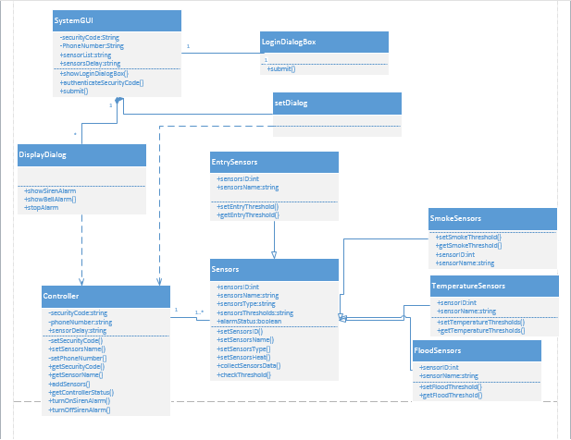

Sequence Diagram:

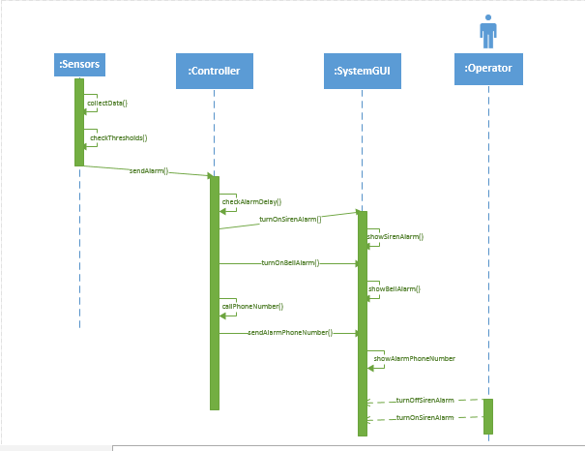

Architecture Diagram:

